# Interactive plots

## Creating interactive maps

### Creating a map and selecting a provider

|  |  |
| --- | --- |
|  | Graphical user interface, text  Description automatically generated  "CartoDB","Esri","CartoDB.PositronNoLabels" |

### Dynamic provider selector

### Adding a blue mark and message from vectors

### Setting popups design

**htmlwidgets::htmlEscape()** function will sanitize characters that may be interpreted as HTML.

### Getting a position from a direction

### Getting a direction from a position

library(tmaptools)

rev_geocode_OSM(x=lon, y=lat,as.data.frame = TRUE)

# the direction is the column “names"

### Selecting a position and zoom in the map

In **setView()** we need to specify the center of the view with lat and log.

### Limiting the map view

#### Fixing the map in a view

Switching dragging to FALSE will prevent panning and setting the min and max zoom arguments will limit the zoom, effectively setting and maintaining the focal point, while preserving the interactive features of our web map.

#### Taking back the user to original position

If users try to pan your map outside of the max bounds they will be automatically bounced back into the boundary.

### Taking out the boundaries and markers

### Adding a circle and message from a dataframe

|  |  |
| --- | --- |
|  |  |

#### Changing points’ color

#### Adding a static legend for categorical data

**colorFactor()** creates a function to relate color and levels.

#### Adding a dynamic legend for categorical data

#### Adding a static legend for numerical data

**colorNumeric()** creates a function to relate color and numbers.

### Setting dynamic provider and legend

### Group many circles in clusters

### leaflet.extras Package

#### Adding a general search bottom

#### Adding a search bottom for our data

#### Adding a reset position bottom

### Adding polygons to our map

slotNames(shp): shows the names

Now let’s use palette color

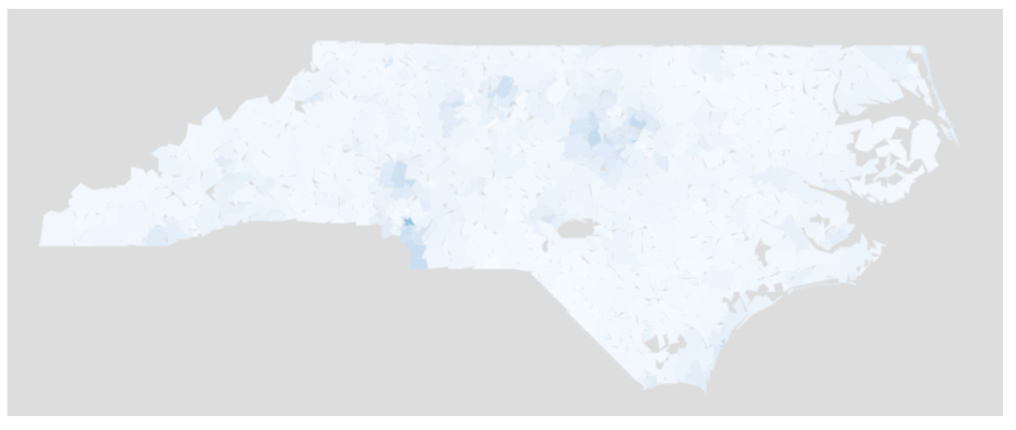

### Let’s see all together

### Exporting our map to html file

